# What sensor to equip the robots with?

## Option 1: Microsoft Kinect

Field of view (FOV) of this sensor is only 57 degrees horizontally. Let’s suppose we attach only 1 front-facing Kinect sensor to each robot. If robot $j$ is randomly placed around robot $i$ at a distance of, say 1.7m meters, the probability of the robot $j$ falling within the field of view of robot $i$’s Kinect sensor is around 16%. Therefore, this option probably won’t provide enough information in order for the learning algorithm to figure out what actions to take to reach or even keep the desired formation.

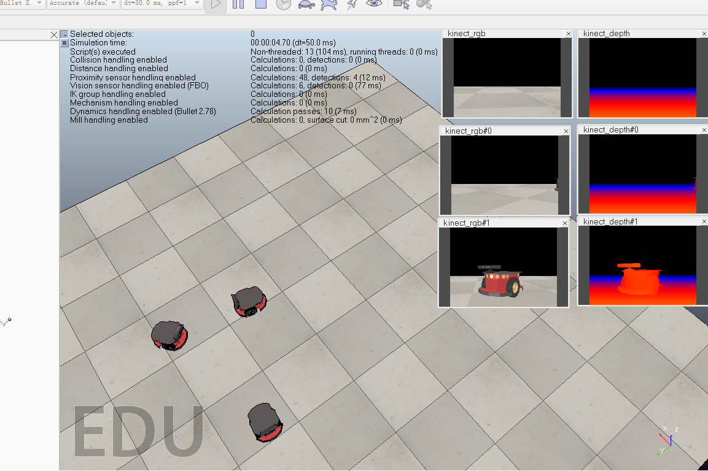

Fig. FOV of Kinect Sensors (1).

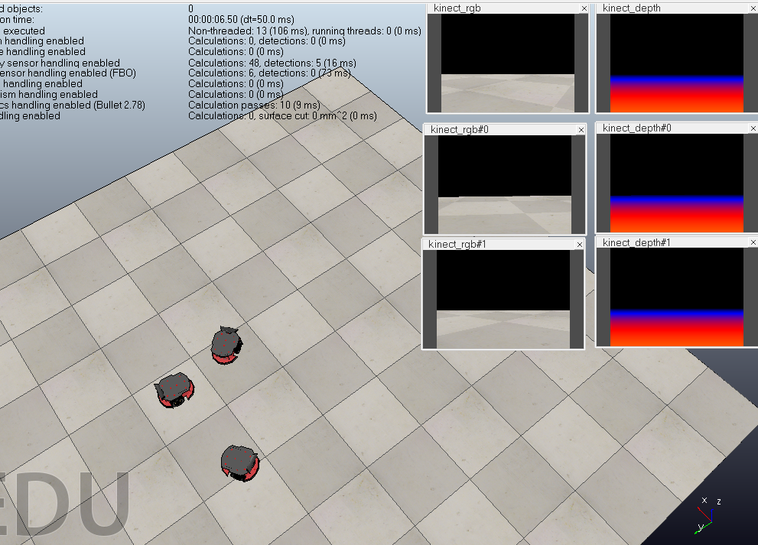

Fig. FOV of Kinect Sensors (2).

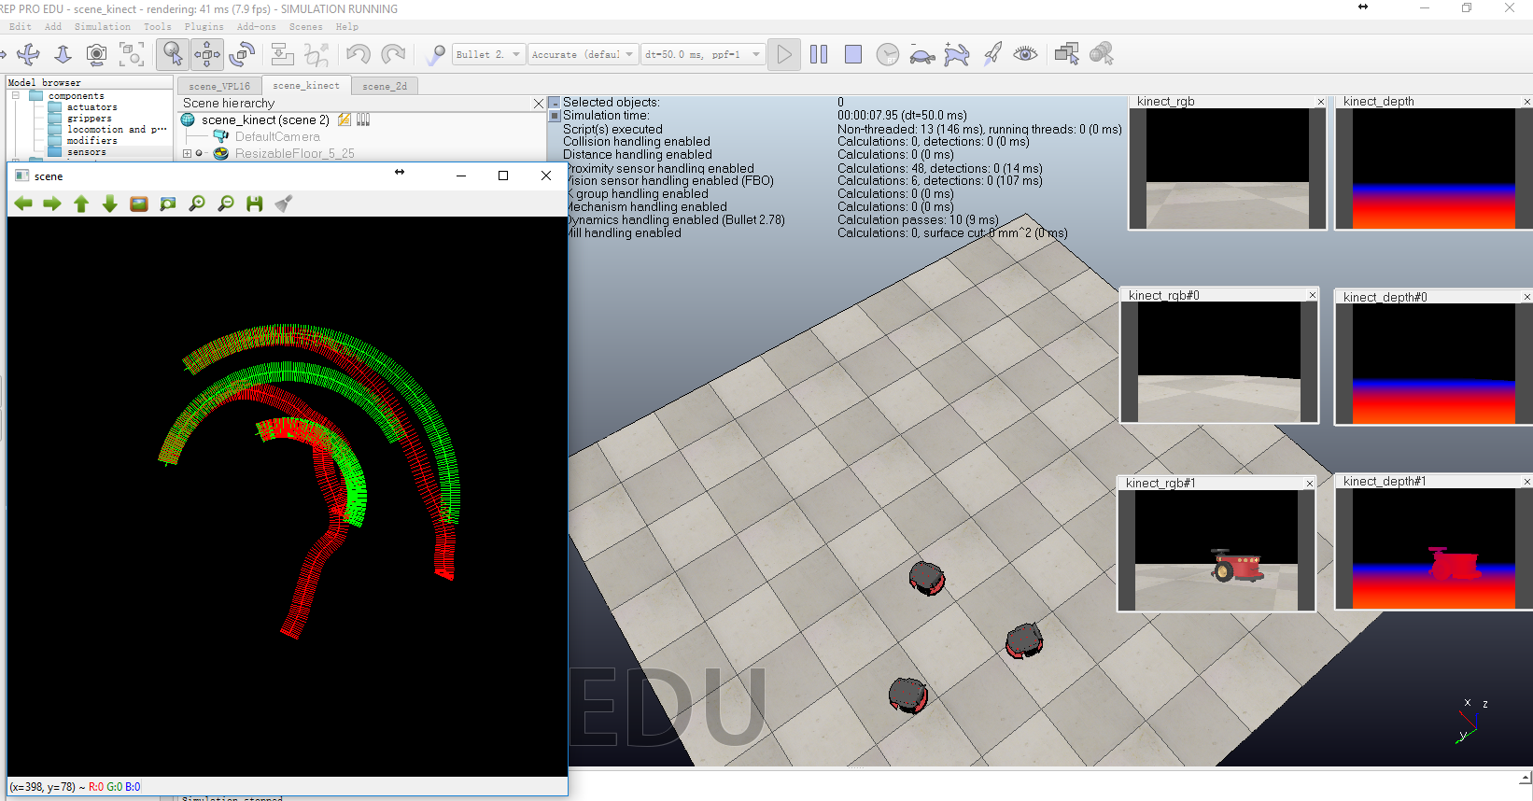

Fig. FOV of Kinect Sensors (3).

## Option 2: 2D Laser Range Finder

The 2D laser range considered here has a $180°$ horizontal FOV. So we have to attach to each robot two of this kind of sensors, one facing the front and the other facing the rear of the robot. As demonstrated by Fig. 4 and Fig. 5, somehow, this sensor is sometimes unable to detect all the other robots even if they are within the sensors’ detection range.

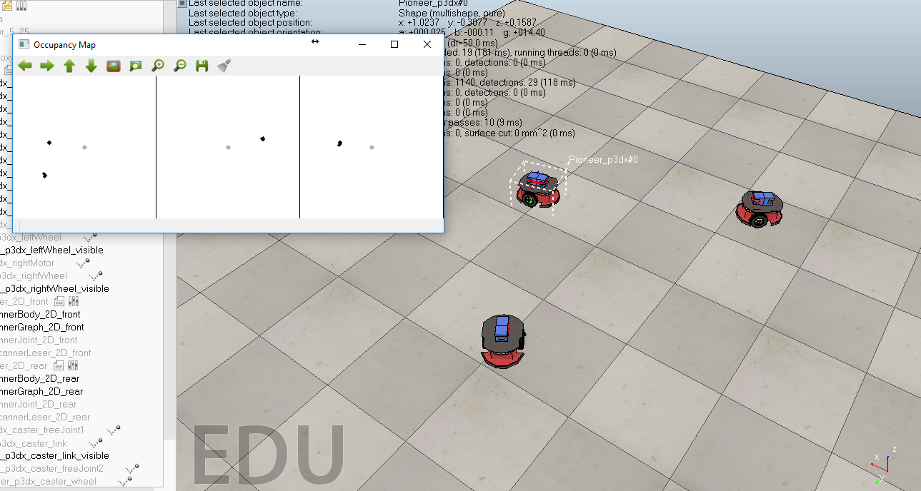

Fig. Occupancy map generated by the 3 2D laser range finders (1). Self position is denoted by a gray solid circle in each occupancy map. Black solid circles represent the positions of the robots sensed relative to the sensor reference frame.

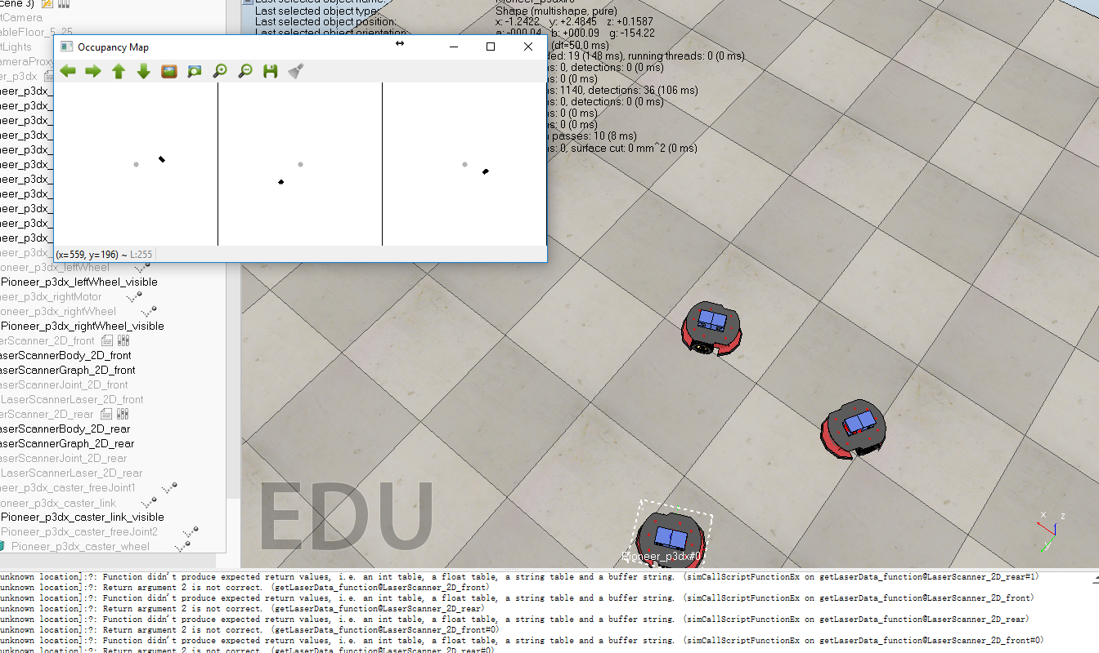

Fig. Occupancy map generated by the 3 2D laser range finders (2). Self position is denoted by a gray solid circle in each occupancy map. Black solid circles represent the positions of the robots sensed relative to the sensor reference frame.

## Option 3: Velodyne VPL16

VPL16 is a 3D laser range finder with a $360°$ horizontal FOV and a $±15°$ vertical FOV. From the raw point cloud data, we can generate the occupancy map at a rate of 5 Hz as shown in Fig. 6. This is by far the most stable sensor in terms of the capability of sensing the other robots.

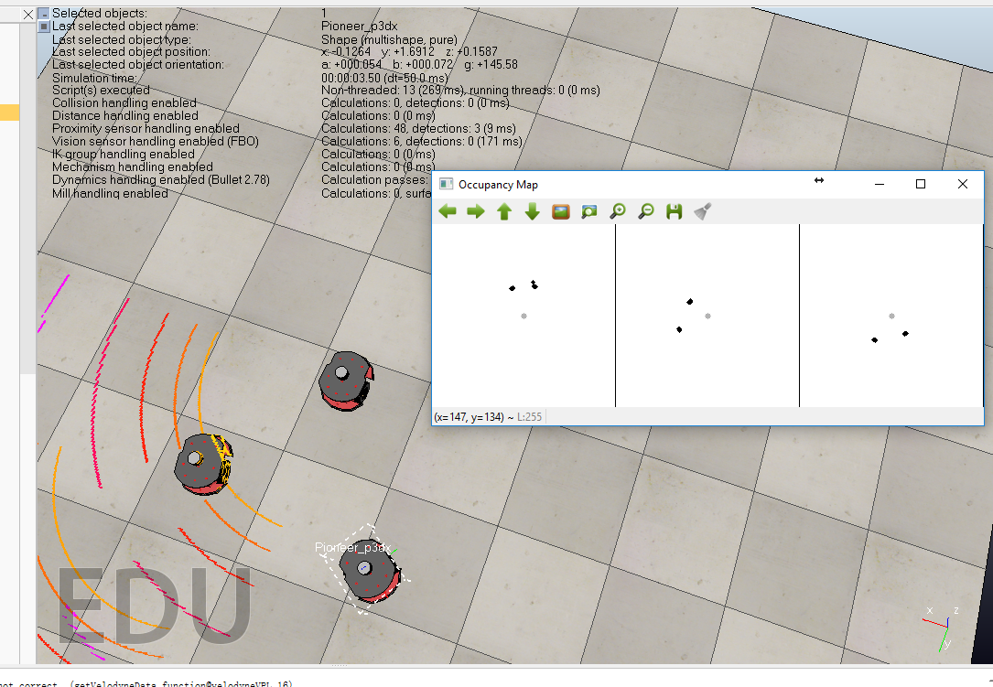

Fig. Occupancy maps generated by the 3 LiDAR sensors. Self position is denoted by a gray solid circle in each occupancy map. Black solid circles represent the positions of the robots sensed by the LiDARs relative to the sensor reference frame.

# Results of model-based formation control

Three robots are controlled to track a circular trajectory in the results shown below.

## Distances between robots that are adjacent in the interaction graph.

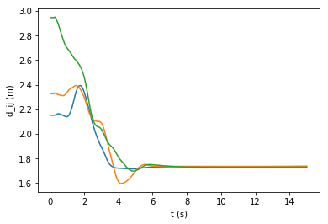

Fig. Distances between robots converge to the desired value 1.732 m.

## Robot formation change with time

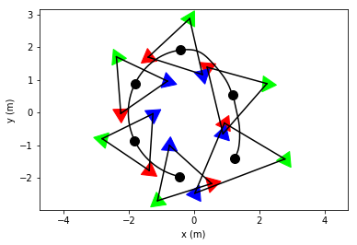

Fig. . The positions of the robots are denoted by triangular markers of different colors. The center of multi-robot system is denoted by a black solid circle. The interaction topology is represented by three edges connecting the robots. As the center tracks a circular trajectory, the lengths of the three edges tend to the desired value 1.732 m.